**Maze Design Mini Report**

As can be seen the drawing in the next page, the bottom plane has holes with even spaces. Each hole has 10 mm diameter. 10 mm holes are not danger for robot movement. That is, there is no drawback of such holes through the robot’s process in the maze. The wall design is given below.

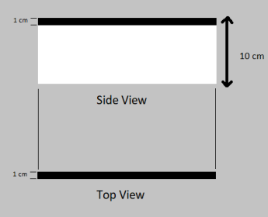

At the bottom of the walls, there are salient parts that go through to the holes on the bottom plane.

There are five different wall parts.

1. 260 mm: smallest wall part. There are be 30 of them.
2. 510 mm: There are 20 of them
3. 760 mm: there are 15 of them
4. 1010 mm: there are 10 of them
5. 1260 mm: there are 3 of them

The varying number of walls allow end user to combine them to number of maze combinations. There is 10 mm surplus at each wall dimensions in order to cover whole area left for walls.

Material is chosen as wooden. Reasons of it are

* Easy to dye
* Cheap
* Easy to produce
* Endurable
* High stiffness properties
* High density compared with foam walls

